Smart Parking System

Description:
The Smart Parking System is an electronics project that helps drivers park vehicles safely by measuring the distance between the car and a wall or obstacle. An ultrasonic sensor detects the distance. If the vehicle gets close to the wall, a yellow LED glows as a warning. When the vehicle is very close, a red LED lights up and a buzzer sounds to alert the driver to stop.
Block Diagram:
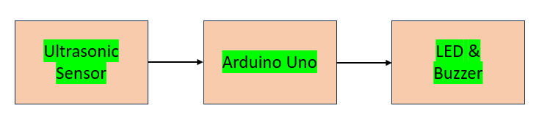
Pinout / Circuit Connection:
Ultrasonic Sensor (HC-SR04) → Arduino
Ultrasonic Pin | Arduino
VCC | 5V
GND | GND
TRIG | D9
ECHO | D10

Component | Arduino Pin
Yellow LED | D6
Red LED | D7
Buzzer | D8
Each LED positive → 220Ω resistor → Arduino pin
Each LED negative → GND

Components Required:
- Arduino UNO
- Ultrasonic Sensor (HC-SR04)
- Yellow LED
- Red LED
- Buzzer
- 2 × 220Ω Resistors
- Breadboard
- Jumper wires
Working Principle:
The ultrasonic sensor works on the principle of sound wave reflection. It sends ultrasonic waves and receives the reflected signal from the obstacle. Arduino calculates the distance using the time taken for the echo to return. Based on this distance, the system activates warning indicators.
- Distance > 20 cm → Safe (no LED)
- Distance between 10–20 cm → Yellow LED ON (vehicle close)
- Distance < 10 cm → Red LED ON + buzzer (vehicle very close)
Operation (Step-by-Step):
- Power ON the Arduino system.
- The ultrasonic sensor continuously measures distance.
- Arduino calculates the distance from the sensor data.
- If the car approaches the wall, the yellow LED turns ON.
- If the car gets very close, the red LED and buzzer activate.
- This alerts the driver to stop the vehicle.
Arduino Code:
#define trigPin 9
#define echoPin 10
#define yellowLED 6
#define redLED 7
#define buzzer 8

void setup() {
pinMode(trigPin, OUTPUT);
pinMode(echoPin, INPUT);
pinMode(yellowLED, OUTPUT);
pinMode(redLED, OUTPUT);
pinMode(buzzer, OUTPUT);
Serial.begin(9600);
}

void loop() {
long duration;
int distance;

digitalWrite(trigPin, LOW);
delayMicroseconds(2);
digitalWrite(trigPin, HIGH);
delayMicroseconds(10);
digitalWrite(trigPin, LOW);

duration = pulseIn(echoPin, HIGH);
distance = duration * 0.034 / 2;

Serial.print("Distance: ");
Serial.println(distance);

if (distance <= 10) {
digitalWrite(redLED, HIGH);
digitalWrite(yellowLED, LOW);
digitalWrite(buzzer, HIGH);
}
else if (distance > 10 && distance <= 20) {
digitalWrite(redLED, LOW);
digitalWrite(yellowLED, HIGH);
digitalWrite(buzzer, LOW);
}
else {
digitalWrite(redLED, LOW);
digitalWrite(yellowLED, LOW);
digitalWrite(buzzer, LOW);
}

delay(500);
}

Conclusion:
The Smart Parking System provides a simple and effective solution for safe vehicle parking. By using an ultrasonic sensor, LEDs, and a buzzer, the system alerts drivers when the vehicle is close or very close to an obstacle, reducing the risk of collisions.
References:
- Arduino Project Hub – Ultrasonic Sensor Tutorial
- Electronics Tutorials – Distance Measurement using HC-SR04

